The Poetry Bubble 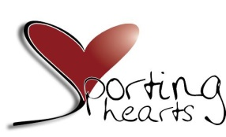
Entry Form
Name

Age DOB (optional)

Address of Electoral Ward

Community Group/ School (If applicable)

Title of Poem/Writing

Short Bio (Optional)

Return all written works to info@sportinghearts.org 5th February 2021
I understand that the work/s I have submitted are my own original writings. I understand that not all submissions may be published. I accept the moderator’s decision as final and no correspondence will be entered into regarding this. I understand that no works/poems will be returned.
Signed:

Date

